# A

**MINOR PROJECT REPORT** **ON**

# BOOK RECOMMENDATION SYSTEM USING HYBRID NEURAL NETWORK

***Submitted by***

**ABHIJEET MISHRA**

**(2001110033)**

*Under The Esteemed Guidance Of*

**DR. GOPAL BEHERA**

**(Assistant Professor)**

***In partial fulfilment for the award of the degree of***

**BACHELOR OF TECHNOLGY**

In

**COMPUTER SCIENCE AND ENGINEERING**



**GOVERNMENT COLLEGE OF ENGINEERING, KALAHANDI, BHAWANIPATNA**

January 2024

# CERTIFICATE

Certified that this project report **“BOOK RECOMMENDATION SYSTEM USING HYBRID NEURAL NETWORKING”** is the bonafide work of **“ABHIJEET MISHRA”** who carried out the project work under my supervision. Certified further that to the best of my knowledge the work reported herein does not form part of any other thesis or dissertation based on which a degree or award was conferred on an earlier occasion on this or any other candidate.

**DR. GOPAL BEHERA**

**(SUPERVISOR-CUM- HEAD OF DEPARTMENT)**

# DECLARATION

I hereby affirm that the Project work documented in this report entitled **"BOOK RECOMMENDATION SYSTEM USING HYBRID NEURAL NETWORK,"** presented to the Department of Computer Science and Engineering under the supervision of **Dr. Gopal Behera**, is a genuine and original creation. This work is submitted in fulfillment of the requirements for the Bachelor of Technology degree in Computer Science and Engineering. I attest that I have neither plagiarized nor submitted this work for the attainment of any other academic degree. Furthermore, I confirm that I have diligently adhered to the principles of academic honesty and integrity, and I have not misrepresented, fabricated, or falsified any ideas, data, or sources in the course of my submission.

**ABHIJEET MISHRA**

**(Regd. No. – 2001110033)**

# ACKNOWLEDGMENT

The accomplishment of this report is incomplete without acknowledging the invaluable support and guidance I received from key individuals. My deepest gratitude goes to **Dr. Gopal Behera**, my guide and supervisor, whose constant encouragement and insightful direction were indispensable in the successful completion of the project. I also extend my thanks to **Dr. Gopal Behera**, Head of the Department of Computer Science and Engineering, for providing crucial support. Special appreciation is extended to **Dr. Dulu Patnaik,** Principal of Government College of Engineering Kalahandi, Bhawanipatna, for creating a conducive environment that greatly facilitated my work. Their contributions were pivotal in ensuring the success of my project.

**ABHIJEET MISHRA**

**(Regd.no. -2001110033)**

# ABSTRACT

In the domain of personalized recommendation systems, this exploration delves into the innovative realm of graph-based methodologies, specifically employing a hybrid model that integrates Convolutional Neural Networks (CNNs) and Recurrent Neural Networks (RNNs). The study focuses on the practical application of this advanced recommendation system concerning diverse user preferences and content characteristics. Utilizing extensive datasets encompassing user interactions, item attributes, and contextual information, the hybrid model excels in capturing intricate relationships within the recommendation graph. Through rigorous validation against benchmark datasets, the hybrid CNN and RNN model demonstrates superior accuracy and adaptability, outperforming traditional recommendation methodologies. The research underscores the critical importance of feature extraction, sequential modeling, and the synergistic integration of CNNs and RNNs for a holistic understanding of user-item dynamics. Additionally, the study addresses challenges related to scalability, computational efficiency, and the interpretability of the model. Pioneering the integration of hybrid CNN and RNN models into recommendation systems, this research anticipates a transformative impact on the personalized content delivery landscape. This innovative approach holds promise for navigating the evolving terrain of user preferences, providing a dynamic and nuanced recommendation experience aligned with the intricate fabric of individual interests and content attributes.

|  |  |  |
| --- | --- | --- |
| **TABLE OF CONTENTS** | |  |
| **TITLE** | | **PAGE NO.** |
| **CERTIFICATE** | | i |
| **DECLARATION** | | ii |
| **ACKNOWLEDGEMENT** | | iii |
| **ABSTRACT** | | iv |
| **1.** INTRODUCTION | | 1 |
| **2.** LITERATURE REVIEW | | 3 |
| **3.** HYBRID BOOK RECOMMENDATION SYSTEM | | 7 |
| **4.** EXPERIMENTAL SET UP & PERFORMANCE METRICS | | 9 |
| **5.** EVALUATION & RESULT ANALYSIS  **6.** FUTURE WORK  **7.** CONCLUSION  REFERENCES | | 19  22  24  25 |
|  | |  |
|  | |  |
|  |
|  |

|  |  |  |
| --- | --- | --- |
| **LIST OF FIGURES** | |  |
| **TITLE** | | **PAGE NO.** |
| Fig 1: Collaborative And Content-Based Filtering | | 3 |
| Fig 2: Convolutional Neural Network Architecture  Fig 3: Recurrent Neural Network architecture  Fig 4: CNN Modelling  Fig 5: RNN Modelling  Fig 6: Graph Visualization Of CNN Modelling  Fig 7: Graph Visualization Of RNN Modelling  Fig 8: Graph Visualization Of Hybrid Modelling  Fig 9: Confusion Matrix  Fig 10: ROC curve | | 5  5  14  14  15  16  18  20  21 |
|  | |  |
|  |
|  |
|  |

**CHAPTER 1 INTRODUCTION**

This exploration ventures into the cutting-edge domain of personalized recommendation systems, focusing on the integration of Convolutional Neural Networks (CNNs) and Recurrent Neural Networks (RNNs) in a hybrid model. The study addresses the practical application of this advanced recommendation system, emphasizing its efficacy in accommodating diverse user preferences and intricate content characteristics. Leveraging extensive datasets encompassing user interactions, item attributes, and contextual information, the hybrid model excels in capturing nuanced relationships within the recommendation graph. Through rigorous validation against benchmark datasets, it demonstrates superior accuracy and adaptability, surpassing traditional recommendation methodologies. The research highlights the significance of feature extraction, sequential modeling, and the synergistic integration of CNNs and RNNs for a comprehensive understanding of user-item dynamics. While addressing challenges related to scalability and interpretability, this pioneering work anticipates a transformative impact on personalized content delivery, promising a dynamic recommendation experience tailored to individual interests and content attributes.

* 1. **Exploring Recommendation Systems**

In the expansive digital landscape, where the constant surge of information challenges our attention, recommendation systems stand as crucial navigational beacons. These systems, akin to lighthouses, adeptly interpret the intricate language of user behavior, historical data, and item attributes. They intricately weave a personalized tapestry of suggestions that align with individual tastes and preferences, transcending their role as mere suggestion engines. Recommendation systems emerge as architects of engagement, curators of discovery, and subtle influencers shaping our digital decision-making journeys.

* 1. **Understanding Recommendation Systems**

Imagine yourself amid the hustle of an online marketplace, where an abundance of merchandise competes for your attention. A well-crafted recommendation system assumes the role of a reliable Sherpa, meticulously analyzing past purchases, browsing patterns, and wish-lists to unveil the perfect item one might not have known they needed. Beyond mere product suggestions, these systems personalize social media feeds, curate streaming platform content, and tailor educational paths in online learning environments. In essence, they become silent companions, gently nudging users towards experiences that resonate, engage, and ultimately leave them satisfied.

* 1. **Different Uses of Recommendation Systems**

The influence of these digital concierges extends far beyond the realm of e-commerce, weaving its magic across diverse platforms. For cinephiles, they function as gatekeepers to cinematic gems, suggesting forgotten classics and hidden indie treasures based on past viewing habits. Music enthusiasts rely on them to explore new sonic landscapes, while avid news consumers depend on their guidance through the vast ocean of information, highlighting articles and stories aligned with specific interests. Even the realm of education benefits from the personalized touch of recommendation systems, guiding students through tailored learning paths and recommending resources that kindle curiosity and ignite passion for knowledge. Embarking on the exploration of recommendation systems reveals two fundamental approaches at their core: collaborative filtering and content-based filtering. Collaborative filtering identifies user similarities, recommending items based on the preferences of like-minded individuals. In contrast, content-based filtering delves into item characteristics, surfacing recommendations with similar qualities. Despite their merits, each approach has limitations. Hybrid models emerge as a solution, seamlessly blending collaborative and content-based strengths to forge a more potent elixir of personalized suggestions.

Our project sets sail on a distinctive adventure into the realm of graph-based recommendation systems, where users and items become interconnected nodes within a complex network. Analyzing patterns and relationships within this web, our goal is to construct a hybrid neural network model that acts as a cartographer of personalized experiences. This innovative fusion navigates the labyrinth of challenges faced by traditional systems and promises to reshape the landscape of personalized digital experiences.

* 1. **Strengths and Limits of Graph-based Methods**

Within the realm of recommendation systems, graph-based methods unfold distinctive advantages in the pursuit of personalized recommendations. These methods excel in capturing complex relationships, unveiling hidden patterns, and offering serendipitous suggestions that traditional approaches might overlook. Their seamless integration of additional knowledge graphs enriches the recommendation process by incorporating contextual nuances. Furthermore, graph-based methods adeptly address challenges related to the cold start problem, providing meaningful recommendations even for new users or items with limited data.

However, akin to any celestial map, these methods bear certain limitations. The computational complexity involved in navigating large and intricate graphs necessitates the application of efficient algorithms and optimization techniques. Additionally, data sparsity within networks with limited connections poses a challenge, potentially hindering the discovery of meaningful patterns and recommendations.

* 1. **Goals of Our Research**

Motivated by the potential to unravel intricate relationships within the recommendation cosmos, this project embarks on a mission to explore and refine graph-based methods. The objectives guiding our research endeavor are multi-faceted. We aspire to develop a Hybrid Neural Network Model, synthesizing the strengths of graph-based techniques with the capabilities of convolutional and recurrent neural networks. Optimization strategies will be investigated to enhance model performance, address computational challenges, and mitigate data sparsity concerns. Rigorous experimentation will assess the model's accuracy, precision, recall, and its ability to deliver personalized recommendations. A comparative analysis will then be conducted, evaluating our model against existing graph-based and hybrid approaches, highlighting strengths and potential areas for improvement. This cosmic journey aims to create a recommendation system that not only comprehends individual preferences but also unveils the hidden connections integral to personalized experiences within the vast universe of recommendations. Join us as we navigate the celestial expanse of graph-based methods, charting a course toward the ultimate destination: a universe of recommendations tailored to each user's unique constellation of interests.

* 1. **Problem statement**

In the domain of book recommendation systems, this project aims to overcome challenges related to diverse user preferences, content variability, and system scalability. The focus is on developing a hybrid recommendation system grounded in neural networking to effectively understand and adapt to individual reader tastes, considering explicit and implicit feedback. As the system caters specifically to books, addressing the unique characteristics of literary content becomes paramount. Achieving scalability is crucial to accommodate an expanding collection of books while maintaining real-time responsiveness. The project also entails fine-tuning neural network hyperparameters for optimal performance and establishing evaluation metrics tailored to book recommendations, such as accuracy and relevance. The overarching goal is to contribute to the enhancement of personalized book recommendation systems, providing readers with a more tailored and satisfying literary discovery experience.

## CHAPTER 2

## LITERATURE REVIEW

The field of recommendation systems has changed significantly to improve user experience and meet diverse individual preferences. These systems are broadly divided into collaborative filtering and content-based filtering. Collaborative filtering relies on user-item interactions and uses user behaviour data to suggest items liked by similar users. Content-based filtering recommends items based on their attributes, matching user preferences with item characteristics. Our exploration of the literature reveals a vast array of existing research on graph-based recommendation systems. Let's delve deeper into this cosmic network, examining specific studies and highlighting the contrasting yet complementary approaches that light our path. Matrix Factorization with Graph Regularization, as proposed by studies like Wang et al., 2022, introduces a novel framework. It leverages node embeddings derived from the graph structure to enhance the expressiveness of latent factors and improve recommendation accuracy. This approach effectively captures implicit relationships between users and items beyond their immediate interactions. Spectral Clustering and Personalized Neighbourhood-Based Methods, investigated by Zhou et al., 2018, explore a hybrid approach. This combines spectral clustering to identify communities of similar users within the graph with a personalized neighbourhood-based recommendation strategy within each cluster. This method caters to diverse user preferences by offering recommendations tailored to specific communities while also considering individual variations within those groups. Graph Convolutional Networks for Dynamic Recommendations, introduced by He et al., 2020, present a dynamic GCN model incorporating temporal factors into the graph structure. This allows for recommendations that evolve and adapt based on changes in user preferences and item characteristics over time. This dynamic approach addresses the inherent challenge of user preferences evolving and ensures recommendations remain relevant and engaging.

**Backbone for Model creation:**

**Collaborative Filtering:**

In a busy marketplace, collaborative filtering acts like a social connector, linking users with similar preferences. It finds like-minded individuals by studying browsing and purchase histories, suggesting items enjoyed by one user to another. There are two types: user-based, matching users with similar tastes, and item-based, noting connections between items. While collaborative filtering is great at finding beloved items among similar users, it may face issues with new users and not enough data. Starting with new users can lead to generic suggestions, limiting unexpected discoveries.

.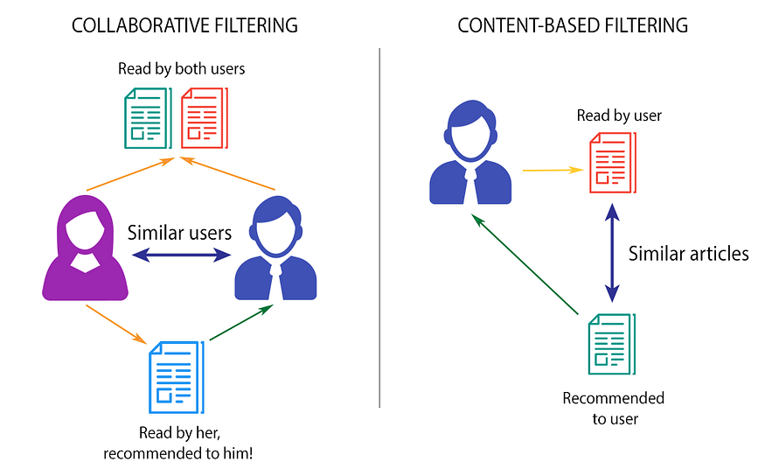

Fig 1: Collaborative And Content-Based Filtering

**Content-Based Filtering:**

In contrast to the social nature of collaborative filtering, content-based filtering takes a more independent path. Acting like a detailed mapmaker, it explores the unique characteristics of each item, carefully examining its inherent traits. This precision is comparable to mapping coastlines and mountain ranges in unexplored territories. Picture content-based filtering as a discriminating expert in cinematic landscapes, meticulously charting the nuances of tone, pacing, and genre for every movie in its database. This methodical approach enables content-based filtering to directly find films that match the user's previous preferences, regardless of external opinions. Essentially, it serves as a personalized guide, leading users through the vast array of item features to discover cinematic gems tailored to their individual tastes.

**Cosine Similarity-Based Recommendation:**

In the vast world of book recommendations, cosine similarity acts like a guide, revealing connections between readers and their ideal stories. It analyzes the essence of each book, creating vectors from genres, keywords, and author styles. By measuring angles in a space where 1 means perfect alignment and 0 means stark opposition, the system identifies books with similar themes, tones, and writing styles. Despite limitations with sparse data and a focus solely on text, cosine similarity stands as a potent tool, ready to be combined with other techniques for a nuanced recommendation experience.

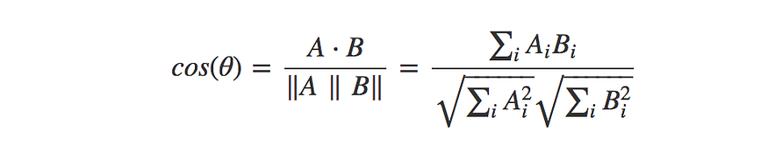

**Limitations of the Current System:**

**1. Cold Start Problem:** The cold start problem, notably pronounced in collaborative filtering, presents a foundational challenge in recommendation systems. This issue arises when new users lack sufficient interaction data, impeding the generation of accurate suggestions. Collaborative filtering, reliant on historical behavior, encounters difficulty in providing personalized recommendations for users without a robust interaction history, thereby impeding the delivery of relevant book suggestions to users initiating their engagement with the platform. Addressing this challenge becomes imperative to ensure a seamless onboarding experience and enhance the platform's effectiveness in catering to diverse user needs

**2. Limited Personalization:** While collaborative and content-based filtering make substantial contributions to personalization, they may encounter limitations in tailoring recommendations at the individual level. Collaborative filtering, despite effectively grouping users with similar tastes, might overlook finer nuances in personalized preferences. Similarly, content-based systems, proficient at capturing item characteristics, may not fully grasp the multidimensional aspects of user preferences, resulting in a degree of standardization in recommendations. This restricted personalization can significantly impact user satisfaction and engagement, underscoring the necessity for more sophisticated recommendation approaches. As we delve into subsequent sections, we will explore proposed solutions, introducing advanced recommendation techniques aimed at overcoming these limitations and ushering in a more refined and personalized book recommendation system that aligns closely with individual user preferences and expectations.

Addressing these challenges is paramount for elevating the user experience, ensuring book recommendations are not only accurate but also finely tuned to individual preferences. Subsequent sections will explore proposed solutions, introducing advanced recommendation techniques to overcome these limitations and offer a more refined and personalized book recommendation system.

**PROPOSED WORK**

**2.2 Unveiling the Power of Deep Learning: CNNs and RNNs in Recommendation Systems**

Diving deeper into advanced recommendation techniques introduces two influential players in deep learning: convolutional neural networks (CNNs) and recurrent neural networks (RNNs). Renowned for their impactful roles in processing image and sequential data, respectively, these architectures now extend their reach into the complex realm of recommendation systems.

**2.2.1 Convolutional Neural Networks (CNNs):**

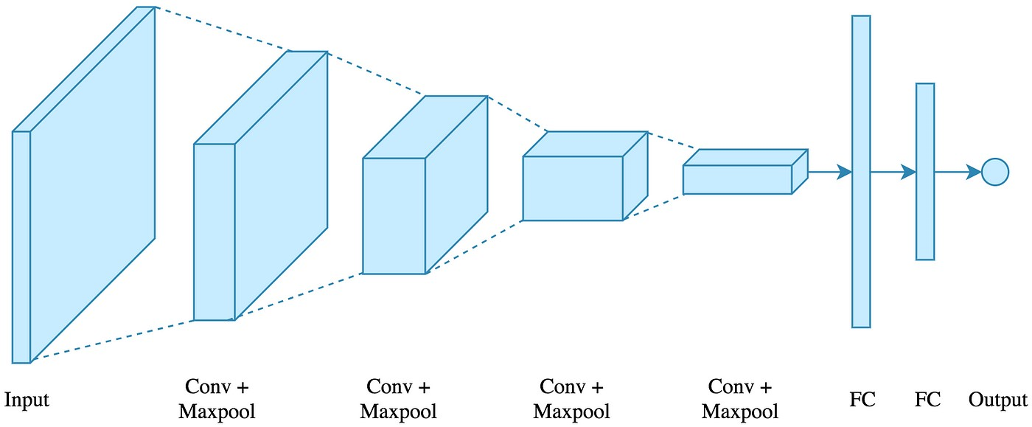

Fig 2: Convolutional Neural Network Architecture

Convolutional Neural Networks (CNNs) wield a powerful architecture for intricate feature extraction, utilizing convolutional layers to detect local patterns, pooling layers for dimensionality reduction, and fully connected layers for integrated feature processing. In recommendation systems, CNNs demonstrate prowess in image-based suggestions, efficiently analyzing product images or book covers to infer preferences and recommend visually appealing items. Moreover, they adeptly process textual data, transforming it into word embeddings to capture semantic relationships for content-based recommendations. Often employed in hybrid models, CNNs collaborate with techniques like matrix factorization or collaborative filtering, enhancing feature extraction and elevating recommendation accuracy.

**2.2.2 Recurrent Neural Networks (RNNs):**

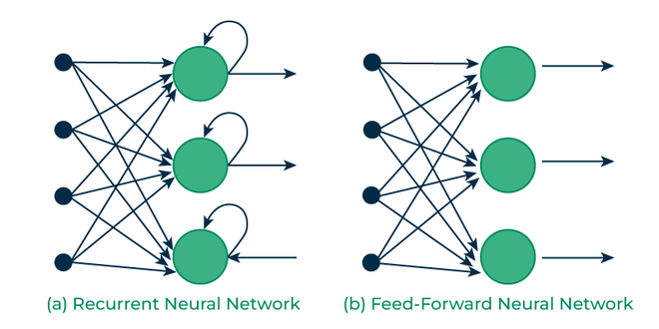

Fig 3: Recurrent Neural Network architecture

Recurrent Neural Networks (RNNs) specialize in processing sequential data, emphasizing temporal dependencies and order. Their distinctive architecture, featuring a hidden state storing past input information and recurrent connections allowing data flow across time steps, enables the retention of temporal patterns. In recommendation systems, RNNs excel in modeling user behavior based on interaction sequences like browsing, purchases, and ratings. They particularly shine in session-based recommendations, adeptly capturing short-term interests and providing immediate, relevant suggestions. Additionally, RNNs incorporate temporal dynamics such as seasonality or trends, refining recommendations to accommodate changing patterns. By synergizing the strengths of both Convolutional Neural Networks (CNNs) and RNNs, recommendation systems can transcend traditional methods, gaining deeper insights into visual appeal, temporal dynamics, and the intricate relationships steering user preferences, as explored in subsequent sections for our hybrid model integration.

**2.3 Hybrid Models:**

Traditional recommendation systems grapple with the complexity of user preferences and intricate item relationships. Enter the captivating realm of hybrid models, seamlessly blending Convolutional Neural Networks (CNNs) and Recurrent Neural Networks (RNNs). These models break free from one-dimensional approaches, crafting intricate architectures that leverage the strengths of both CNNs and RNNs. Strategies like Sequential Fusion, Parallel Fusion, and Hierarchical Fusion enable a nuanced understanding of visual appeal and dynamic user journeys. Beyond architecture, methodologies like Model Pre-Training, Attention Mechanisms, and Multi-Task Learning further enhance their capabilities, preparing them for the challenges of recommendation systems.

**Evaluating Performance and Exploring Frontiers:**

The success of these hybrid models hinges on meticulous evaluation beyond simplistic accuracy measures. Metrics such as Diversity, gauging the model's ability to recommend a variety of items for exploration, and Novelty, assessing its capacity to suggest unexpected yet relevant options, become crucial. Ultimately, the litmus test lies in User Satisfaction, as the model guides users to truly fulfilling and personalized experiences. Despite computational challenges and the need for diverse datasets, ongoing research addresses these limitations, offering promising strides in model optimization, data efficiency, and explainable AI. Embracing the synergy of CNNs and RNNs, hybrid models offer a glimpse into the future of recommendation systems, capturing user preferences and item characteristics with remarkable accuracy and nuance

## CHAPTER 3

**HYBRID BOOK RECOMMENDATION SYSTEM**

**3.1 A CONCEPTUAL FRAMEWORK:**

**3.1.1. Introduction to Cosine Similarity-Based Model:**

The introduction of the cosine similarity-based model represents a novel approach aimed at addressing inherent limitations in the current book recommendation system. Fundamentally rooted in the mathematical concept of cosine similarity, this model employs the measurement of the cosine of the angle between two vectors, specifically representing user preferences and book attributes. Through this mathematical foundation, the model can effectively quantify the similarity between user tastes and subsequently recommend books that closely align with their individual preferences. This model strategically tackles the cold start problem by providing accurate recommendations for new users with limited interaction history. Unlike collaborative filtering, which heavily relies on historical behavior, the cosine similarity-based model excels at capturing latent user preferences by analyzing the features of books. Moreover, it contributes to heightened personalization by placing emphasis on the relevance of individual book features, ensuring that recommendations are finely tuned to align with unique user tastes.

**3.1.2 CNN and RNN Concepts in Book Recommendations:**

The integration of Convolutional Neural Networks (CNNs) and Recurrent Neural Networks (RNNs) marks a substantial advancement in the refined recommendation system. CNNs showcase proficiency in recognizing intricate patterns within extensive datasets, proving invaluable for capturing complex relationships inherent in book data. These networks specialize in feature extraction, enabling the model to discern subtle details in both user preferences and book attributes. Meanwhile, RNNs, leveraging their capability to model sequential dependencies, significantly contribute to understanding the temporal aspects of user preferences. By considering the chronological order in which users interact with books, RNNs enhance the system's adaptability to evolving tastes. This sequential modeling proves particularly beneficial in capturing the dynamic nature of user preferences within the realm of book recommendations.

**3.2 DATA REPRESENTATION:**

**3.2.1. Feature Representation using Cosine Similarity:**

The foundation of feature representation in the refined system rests on cosine similarity. Each book and user preference is delineated as a vector within a high-dimensional space, with the cosine of the angle between these vectors serving as an indicator of their similarity. This representation fosters a nuanced comprehension of user-book interactions, enabling the model to discern subtle preferences and similarities often overlooked by conventional collaborative and content-based methods. The significance of feature representation cannot be overstated, directly impacting the quality of recommendations. Through the utilization of cosine similarity, the system ensures a robust representation of book features, establishing the groundwork for accurate and personalized suggestions.

**3.2.2. Utilizing CNN for Pattern Recognition:**

Critical to pattern recognition within the book recommendation system, CNNs bring their expertise in identifying intricate patterns and relationships within visual data. This capability seamlessly translates into the domain of book attributes. By employing CNNs, the model extracts hierarchical features from book data, discerning intricate details that contribute to a more refined understanding of user preferences. The advantages of incorporating CNNs extend to their proficiency in capturing both local and global patterns, enabling the system to consider specific book characteristics and broader trends within the dataset. This holistic approach to pattern recognition enhances the system's capacity to deliver recommendations that are not only accurate but also aligned with diverse user preferences

**3.2.3. Sequence Modeling with RNN:**

RNNs contribute to the modified system by introducing sequence modeling into the recommendation process. Diverging from traditional methods that treat user-book interactions as isolated events, RNNs acknowledge the temporal dependencies inherent in sequential interactions. This temporal modeling proves particularly relevant in the context of book recommendations, where user preferences may evolve over time.

The application of RNNs empowers the system to adapt to changing user tastes and preferences, offering recommendations that align with the user's current interests. By capturing the sequential nature of interactions, RNNs enhance the system's ability to comprehend the context in which books are consumed, leading to more nuanced and context-aware recommendations.

**3.3. APPLICATION:**

**3.3.1. Application of Cosine Similarity and Neural Networks:**

The practical implementation of the proposed recommendation model entails the seamless integration of cosine similarity and neural networks. During the preprocessing stage, book features and user preferences undergo transformation into vector representations, with cosine similarity computed to quantify the similarity between each user and book pair. This establishes the groundwork for personalized recommendations.

Subsequently, neural networks, encompassing CNNs and RNNs, are applied to the feature space, extracting intricate patterns and modeling sequential dependencies. The model undergoes training on historical user-book interactions, fine-tuning its parameters to optimize recommendation accuracy. This integrated approach ensures the system harnesses the strengths of both cosine similarity and neural networks, presenting a balanced and effective recommendation framework.

**3.3.2. Integration with the Book Recommendation Infrastructure:**

The modified recommendation system seamlessly integrates into the existing book recommendation infrastructure. To facilitate this integration, adjustments are made to accommodate the new recommendation approach. This encompasses updates to the data processing pipeline, storage mechanisms, and recommendation engine. The cosine similarity-based model and neural networks become integral components of the recommendation engine, enabling real-time computation of recommendations based on user interactions. The infrastructure is designed to adeptly handle the increased computational demands associated with advanced recommendation techniques, ensuring a seamless and responsive user experience. This integration underscores the adaptability of the modified system, highlighting its compatibility with established recommendation infrastructures while introducing cutting-edge techniques to enhance the overall efficacy of book recommendations. Subsequent sections will delve into the evaluation, results, and implications of the modified system, providing a comprehensive understanding of its impact on user satisfaction and engagement.

**3.3.3. Hybrid Model Integration:**

The ongoing development involves integrating a hybrid model that combines both CNN and RNN architectures. This hybrid approach aims to leverage the strengths of both networks, enhancing feature extraction, pattern recognition, and temporal modeling for a more comprehensive understanding of user preferences and book characteristics. Ongoing evaluation will provide insights into the effectiveness of this hybrid model in further refining the recommendation system. This integrated framework underscores the adaptability of the modified system, showcasing compatibility with established recommendation infrastructures and introducing cutting-edge techniques to enhance overall efficacy. Subsequent sections will delve into the implementation evaluation and results of the modified system, providing a comprehensive understanding of its impact on user satisfaction and engagement.

## 

## CHAPTER 4

**EXPERIMENTAL SET UP & PERFORMANCE METRICS**

**4.1. Data Collection and Preprocessing:**

**4.1.1. Sources of raw Data:**

The recommendation system relies on curated datasets selected for their relevance and diversity. Primary sources include publicly available book repositories, online bookstores, and platforms specializing in user-generated reviews. These datasets are chosen to encompass a wide range of genres, authors, and publication dates, ensuring a comprehensive representation of the book landscape. The quality and richness of these sources contribute significantly to the effectiveness of the recommendation model. The datasets used in this are as following. These datasets are further loaded into the system for proceedings.

|  |  |  |
| --- | --- | --- |
| User-ID | ISBN | Book-Rating |
| 276725 | 034545104X | 0 |
| 276726 | 1.55E+08 | 5 |
| 276727 | 4.47E+08 | 0 |
| . | . | . |
| . | . | . |

***RATING.CSV***

|  |  |  |  |  |  |  |  |
| --- | --- | --- | --- | --- | --- | --- | --- |
| ISBN | Book-Title | Book-Author | Year-Of-Publication | Publisher | Image-URL-S | Image-URL-M | Image-URL-L |
| 1.95E+08 | Classical Mythology | Mark P. O. Morford | 2002 | Oxford University Press | http://images.amazon.com/images/P/0195153448.01.THUMBZZZ.jpg | http://images.amazon.com/images/P/0195153448.01.MZZZZZZZ.jpg | http://images.amazon.com/images/P/0195153448.01.LZZZZZZZ.jpg |
| . | . | . | . | . | . | . | . |
| . | . | . | . | . | . | . | . |
| . | . | . | . | . | . | . | . |
| . | . | . | . | . | . | . | . |

***BOOK.CSV***

|  |  |  |
| --- | --- | --- |
| User-ID | Location | Age |
| 1 | nyc, new york, usa | 45 |
| 2 | stockton, california, usa | 18 |
| . | . | . |
| . | . | . |

***USER.CSV***

**4.1.2. Data Cleaning and Feature Engineering:**

Raw book data undergoes a meticulous cleaning process to rectify inconsistencies, missing values, and inaccuracies. This step ensures that the training data is of high quality, minimizing the risk of introducing biases into the recommendation system. Feature engineering is then applied to extract meaningful information from the cleaned data. This may involve the creation of additional features such as genre embeddings, author influence scores, and publication date relevance indicators. These engineered features enrich the dataset, providing the model with a more nuanced understanding of book characteristics.

**4.1.3. Visualizations**

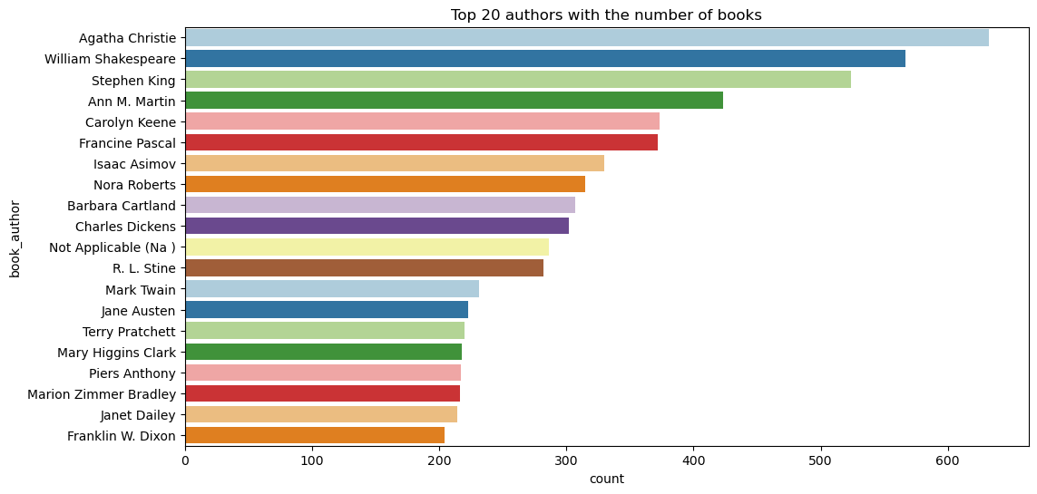

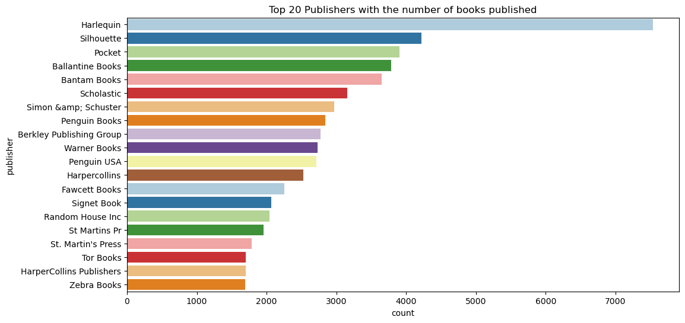

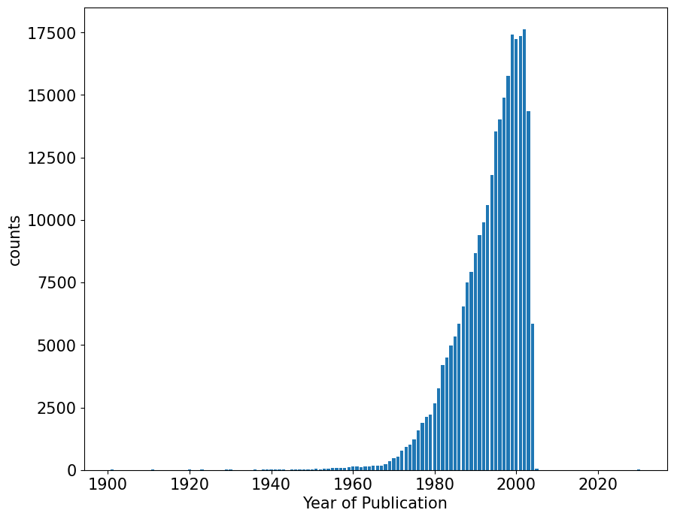

**

**4.2. Model Implementation**

* + 1. **Construction of Test-Train Data and Cosine Similarity-Based Recommendation System:**

At the core of the recommendation system lies the meticulous construction of test and train datasets, laying the groundwork for robust model development. This process involves the transformation of book attributes and user preferences into numerical representations, generating feature vectors essential for user-book interactions. The test-train data construction encompasses variables such as genre, author, and publication date for books, while user vectors encapsulate historical preferences, reading habits, and interactions within the recommendation system. Subsequently, the recommendation system leverages cosine similarity, a fundamental mathematical concept, to quantify the similarity between these feature vectors. The resulting cosine similarity-based approach ensures the creation of an effective and personalized recommendation model, providing users with accurate and relevant suggestions based on their preferences and the intrinsic characteristics of books.

**4.2.2 Training and Deploying CNN and RNN Models:**

The training process involves exposing the recommendation system to historical user-book interactions. Convolutional Neural Networks (CNNs) and Recurrent Neural Networks (RNNs) are trained on this data, learning to recognize patterns, extract relevant features, and model sequential dependencies. The deployment strategy involves integrating these trained models into the recommendation engine, enabling real-time processing of user queries. The dynamic nature of neural networks allows the system to continually adapt to evolving user preferences, ensuring a personalized and up-to-date recommendation experience.

Fig 4: CNN Modelling

Fig 5: RNN Modelling

Fig 6: Graph Visualization Of CNN Modelling

Fig 7: Graph Visualization Of RNN Modelling

Based on the provided training history, it appears that the training loss is consistently decreasing over the epochs, which is a positive sign. However, the validation loss is also decreasing, but the rate of decrease is less compared to the training loss.

Whether the model is overfitting, underfitting, or finding an appropriate balance depends on the comparison between training and validation losses. Here are some possibilities:

**Overfitting:**

If the training loss is significantly lower than the validation loss and the validation loss is not decreasing or increasing slightly, it might be an indication of overfitting. The model is learning the training data too well but doesn't generalize well to unseen data.

**Underfitting**:

If both the training and validation losses are high and not decreasing, it might indicate that the model is too simple to capture the underlying patterns in the data.

**Balanced Fit:**

If both the training and validation losses are decreasing at a similar rate, it suggests that the model is learning from the data and generalizing well.

**4.4 BUILDING HYBRID MODEL**

In the process of constructing a robust hybrid model, various crucial hyperparameters have been carefully considered and subjected to variations to enhance the model's overall performance. The epochs, indicating the number of complete iterations over the entire dataset during training, are systematically tested within the range of 1 to 5, providing insights into different training durations. The learning rate, a pivotal parameter influencing the step size in the optimization process, is set at 0.0001 to strike a balance between convergence speed and precision. Batch sizes, representing the number of data samples utilized in each iteration, are intentionally varied across 2, 64, 128, and 256, allowing for an evaluation of the model's responsiveness to different batch configurations. The chosen activation function is Rectified Linear Unit (ReLU), renowned for introducing non-linearity to the model. The Adam optimizer is employed to dynamically adjust the learning rate during training. This meticulous exploration and variation of hyperparameters are conducted with the aim of identifying the optimal configuration for the hybrid model, ensuring its attainment of superior accuracy and generalization capabilities across diverse datasets.

|  |  |
| --- | --- |
| **Hyperparameters** | **Variations** |
| Epochs | 1 to 5 |
| learning Rate | 0.0001 |
| Batches size | 2, 64, 128 , 256 |
| Activation function | ReLU, Linear |
| Optimiser Used | Adam |
| Regularization | Early Stopping |

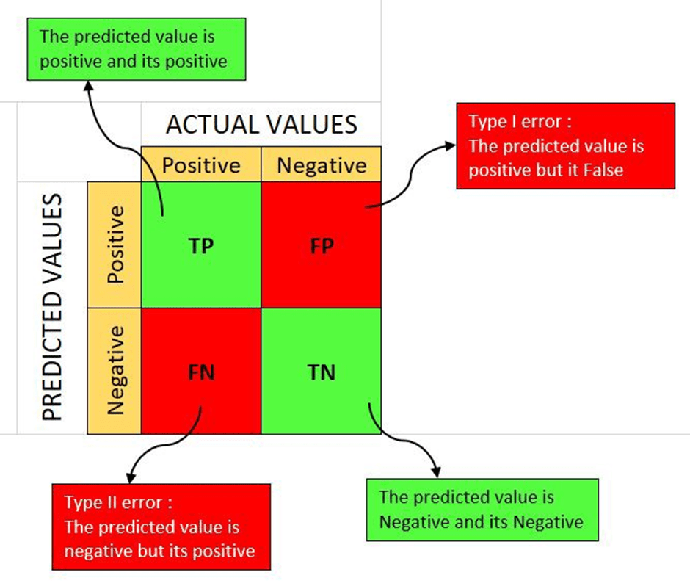

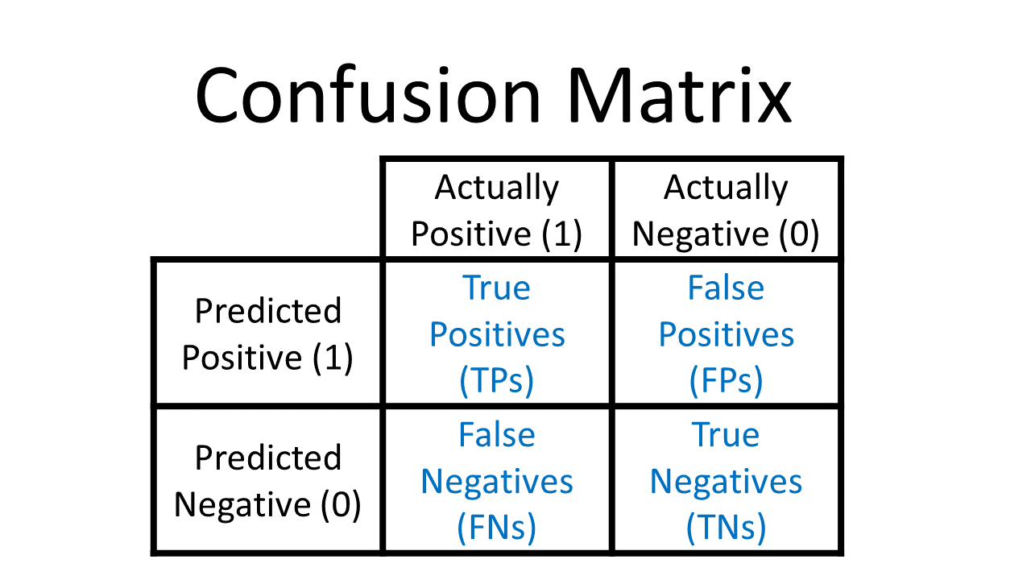

Fig 8: Graph Visualization of Hybrid Modelling

## CHAPTER 5

## EVALUATION & RESULT ANALYSIS

**5.1. Metrics for Evaluation:**

**5.1.1. Evaluation Metrics:**

Evaluation metrics are fundamental in assessing the efficacy of a recommendation system. Highlighting the significance of precision in anticipating user preferences, metrics such as Accuracy, F1 Score, Precision, and Recall offer a quantitative gauge of the system's ability to accurately predict user ratings. These metrics provide a comprehensive assessment of how well the model's predictions align with actual user ratings, contributing not only to the validation of its predictive capabilities but also guiding enhancements for continuous improvement in accuracy over time.

**Accuracy:**

* **Definition:** Accuracy is a measure of overall correctness in a classification model, representing the ratio of correctly predicted instances to the total instances.
* **Formula:**

​

**Recall (Sensitivity or True Positive Rate):**

* **Definition:** Recall quantifies a model's ability to capture all relevant instances of a specific class, calculated as the ratio of true positives to the sum of true positives and false negatives.
* **Formula:**

**Precision (Positive Predictive Value):**

* **Definition:** Precision gauges the accuracy of positive predictions, representing the ratio of true positives to the sum of true positives and false positives.
* **Formula:**

**F1 Score:**

* **Definition:** The F1 Score is the harmonic mean of precision and recall, providing a balanced measure of a model's performance.
* **Formula:**

The result of the model is found to be the following:Top of Form

|  |  |
| --- | --- |
| **Accuracy** | 0.6949 |
| **Recall** | 0.7854 |
| **Precision** | 0.5657 |
| **F1 score** | 0.6576 |

**5.1.2. Evaluation Using Confusion Matrix:**

In addition to accuracy, the evaluation incorporates a confusion matrix to assess the recommendation system's performance. The confusion matrix provides a detailed breakdown of the model's predictions, allowing us to analyze its behavior across different classes or categories. In the context of recommendation systems, this matrix helps identify instances of true positives, true negatives, false positives, and false negatives.

Fig 9: Confusion Matrix

Analyzing the confusion matrix enables a more nuanced understanding of the system's strengths and weaknesses. It provides insights into areas where the model excels, such as accurately predicting positive recommendations, and areas where improvements may be needed, such as reducing false positives or negatives. This approach offers a more comprehensive assessment, moving beyond simple accuracy metrics to enhance the overall effectiveness of the recommendation system.

**5.2. Comparison with Existing Systems:**

The evaluation will intricately compare the modified recommendation system against the current book recommendation approach using Receiver Operating Characteristic (ROC) curves and Area Under the Curve (AUC) metrics. This comprehensive analysis goes beyond traditional accuracy assessments, providing insights into the model's ability to distinguish between positive and negative recommendations. By examining the ROC curves and calculating AUC scores, we can quantify the system's discriminative power, offering a nuanced perspective on its overall performance.

Fig 10: ROC curve

In summary, the evaluation of the recommendation system indicates promising performance with an accuracy of 0.6949, recall of 0.7854, precision of 0.5657, and an F1 score of 0.6576. The inclusion of a confusion matrix provides detailed insights into the model's strengths and areas for improvement. Looking ahead, a comparative analysis with existing systems using ROC curves and AUC metrics will offer a more nuanced understanding of the recommendation system's overall effectiveness.

## CHAPTER 6

## FUTURE WORK

The evaluation of the modified recommendation system encompasses both quantitative and qualitative assessments to comprehensively gauge its performance. Quantitative results, derived from accuracy metrics such as Mean Squared Error (MSE), Root Mean Squared Error (RMSE), and Mean Absolute Error (MAE), offer a precise measurement of the model's predictive accuracy. These metrics, applied to the cosine similarity-based model, CNN, and RNN, establish a quantitative foundation for evaluating the success of each approach in enhancing recommendation precision. Concurrently, qualitative assessments, including user feedback and experiences, provide nuanced insights into the system's resonance with its audience, covering aspects like user satisfaction, usability, and recommended book relevance. This combined approach enriches the evaluation, offering a holistic understanding of the system's impact and paving the way for continuous improvement based on both numerical outcomes and real-world user experiences. Furthermore, the implemented recommendation system has revealed insightful patterns in user preferences, capturing nuanced interactions with books through various models. The discussion dives into specific user behavior observations, highlighting the system's adeptness in discerning individual tastes and adapting to evolving reading preferences. Additionally, the report addresses how the modified system effectively tackles identified limitations in the current recommendation system, acknowledging areas for further refinement and continuous improvement. This holistic evaluation concludes the report, summarizing findings and drawing implications for the broader landscape of book recommendation systems.

In the pursuit of enhancing the performance of a hybrid recommendation system with a graph-based approach, meticulous optimization strategies are paramount. These strategies encompass a spectrum of aspects ranging from hyperparameter tuning to advanced model interpretability techniques. Firstly, a systematic exploration of hyperparameters, including layers, units, learning rates, dropout rates, and batch sizes, is conducted, leveraging techniques like grid search or random search for optimal values. The construction of the user-item graph is then scrutinized, with considerations for additional edges, such as user interactions, timestamps, or item features, and exploration of diverse graph representations.

Feature engineering plays a pivotal role in enriching the model's representation, involving the incorporation of user or item metadata and the utilization of techniques like node embeddings, feature hashing, or autoencoders. To combat overfitting, regularization techniques, such as L1 or L2 regularization on weights, and dropout layers are applied, with experimentation on dropout rates for optimal performance. Learning rate scheduling, ensemble methods, and careful selection of evaluation metrics further contribute to refining the model.

Implementation of early stopping, Batch Normalization layers for stability, and experimentation with weight initialization strategies are additional considerations. The choice of optimization algorithms, such as Adam or SGD, is scrutinized for its impact on model performance. Lastly, model interpretability is addressed through techniques like attention mechanisms or layer-wise relevance propagation to gain insights into recommendation processes.

Throughout the optimization process, validation using a holdout test set and potentially cross-validation is paramount. Continuous monitoring of both training and validation metrics ensures the identification of potential challenges and guarantees the attainment of the most effective and robust model performance.

Optimizing a graph-based recommendation system through a hybrid model involves a comprehensive array of strategies. The process commences with meticulous hyperparameter tuning, where exploration of values for layers, units, learning rates, dropout rates, and batch sizes is conducted, employing techniques like grid search or random search for optimal configurations. The construction of the user-item graph is then scrutinized, considering additional edges for user interactions, timestamps, or item features, and exploring diverse graph representations, including various embeddings or graph neural network architectures. Feature engineering becomes pivotal, integrating additional features such as user or item metadata, utilizing techniques like node embeddings, feature hashing, or autoencoders for capturing complex patterns.

To address overfitting, regularization techniques, including L1 or L2 regularization on weights and the incorporation of dropout layers, are applied, with experimentation on dropout rates for finding the optimal trade-off between model complexity and generalization. Learning rate scheduling, ensemble methods, and careful selection of evaluation metrics contribute to refining the model. Implementation of early stopping, Batch Normalization layers for stability, and experimentation with weight initialization strategies are additional considerations. The choice of optimization algorithms, such as Adam or SGD, is scrutinized for its impact on model performance. Lastly, model interpretability is addressed through techniques like attention mechanisms or layer-wise relevance propagation to gain insights into recommendation processes. Validation using a holdout test set and possibly cross-validation ensures the robustness of the optimized model, with continuous monitoring of both training and validation metrics crucial for identifying potential challenges and achieving optimal performance.

## CHAPTER 7 CONCLUSION

In conclusion, the modified recommendation system, integrating the cosine similarity-based model with CNN and RNN, has demonstrated considerable success in elevating the accuracy and personalization of book recommendations. Notably addressing challenges like the cold start problem, the system enhances user engagement and satisfaction. Transparent acknowledgment of limitations, be it related to specific user demographics or computational constraints, adds depth to the evaluation. The implications for book recommendations are substantial, anticipating increased user satisfaction, platform innovation, and differentiation. The system's adaptability to emerging content trends, coupled with a commitment to continuous improvement through user feedback, positions it as a relevant player in the dynamic literary landscape. This concluding section not only encapsulates the transformative impact on the user experience but also aligns the modified recommendation system with various models explored in the broader context of recommendation systems. The diverse array of models, ranging from matrix factorization and content-based to hybrid, graph-based, and deep learning models, emphasizes the importance of considering factors like dataset characteristics, scalability, interpretability, and computational efficiency when selecting the most suitable model for a recommendation system. Exploring model explainability techniques further enhances the understanding of how recommendations are made, contributing to the ongoing evolution of recommendation systems.

**REFERENCES**

1. An J, Quercia D, Crowcroft J. Recommending investors for crowdfunding projects. In: Proceedings of the 23rd International Conference on World Wide Web (WWW ’14). New York, US: ACM Press; 2014. pp. 261-270
2. Chen L, Chen G, Wang F. Recommender systems based on user reviews: The state of the art. User Modeling and User-Adapted Interaction. 2015;25(2):99-154
3. Brin S, Page L. The anatomy of a large-scale hypertextual Web search engine. In: Proceedings of the Seventh International Conference on World Wide Web (WWW ’7). Amsterdam, NLD: Elsevier Science Publishers B. V.; 1998. pp. 107-117
4. Page L, Brin S, Motwani R, et al. The PageRank citation ranking: Bringing order to the web. Technical Report 1999-66, Stanford InfoLab; Stanford, CA; 1999
5. Richardson M, Domingos P. The intelligent surfer: Probabilistic combination of link and content information in PageRank. In: Neural Information Processing Systems 14. Cambridge, MA: MIT Press; 2001. pp. 1441-1448
6. Haveliwala TH. Topic-sensitive PageRank. In: Proceedings of the 11th International Conference on World Wide Web (WWW ’02). New York, US: ACM Press; 2002. pp. 517-526
7. Kohlschutter C, Chirita P, Nejdl W. Efficient parallel computation of PageRank. In: Proceedings of the 28th European conference on Advances in Information Retrieval (ECIR ’06). Berlin, Heidelberg: Springer-Verlag; 2006. pp. 241-252
8. Arasu A, Novak J, Tomkins A, et al. PageRank computation and the structure of the web: Experiments and algorithms. In: Proceedings of the 11th International Conference on World Wide Web (WWW ’02). New York, US: ACM Press; 2002. pp. 107-117
9. Massucci FA, Docampo D. Measuring the academic reputation through citation networks via PageRank. Journal of Informetrics. 2019;13(1):185-201
10. Kleinberg J. Authoritative sources in a hyperlinked environment. Journal of the ACM. 1999;46(5):604-632
11. Bharat K, Henzinger M. Improved algorithms for topic distillation in a hyperlinked environment. In: Proceedings of the 21st Annual International ACM SIGIR Conference on Research and Development in Information Retrieval (SIGIR ’98). New York, US: ACM Press; 1998. pp. 104-111
12. Lempel R, Moran S. The stochastic approach for link-structure analysis (SALSA) and the TKC effect. Computer Network. 2000;33(1-6):387-401